To join the Employment and Skills Dynamic Purchasing System (DPS) by submitting a Selection Questionnaire (SQ), you’ll need to:

- Login into Mercell YORtender (eu-supply.com)
- Near the top left of your home screen click the link ‘CTM Published Tenders’

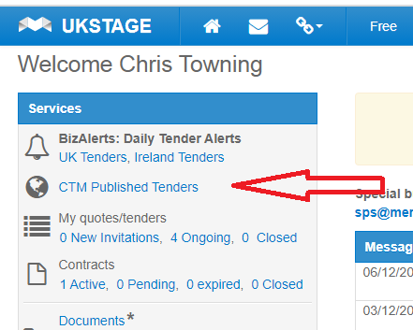

- On the Ongoing Public Tenders, click on the link for ‘Employment and Skills Dynamic Purchasing System DN310329’
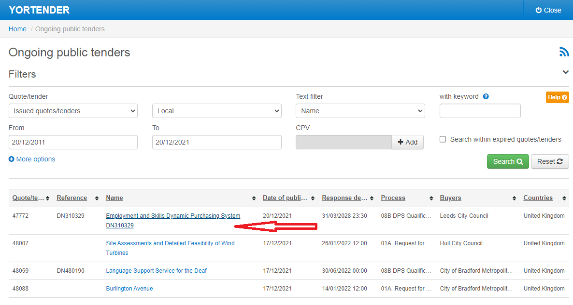

- If it’s not on the list (step 3 above) because there’s been a lot of other Tenders that have gone live since the DPS did, please follow this:
- Choose: All
- Set text filter to: Name
- Enter Keyword: DN310329
- Set to Date as 31/03/2028
- Click the search button

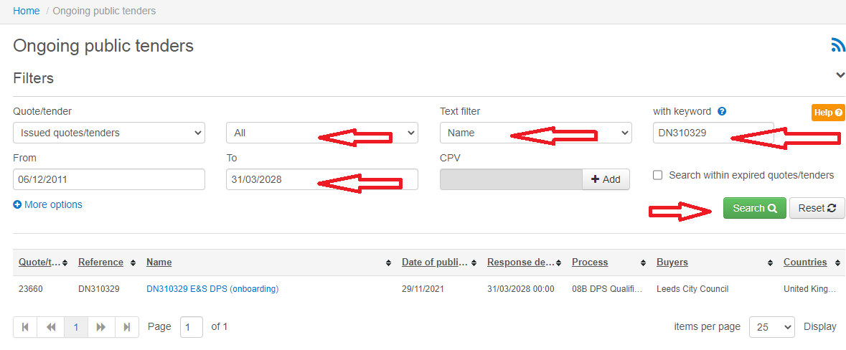

- Click on the hyperlink to DN310329 E&S DPS in the search result list. This will take you to the E&S DPS pages
- Click Accept at the top of the E&S DPS page

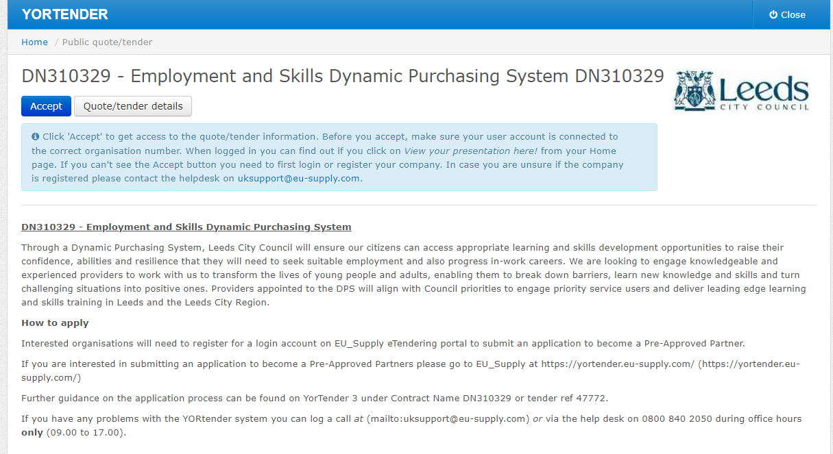

- Under Quote/tender click on ‘Access Documents’

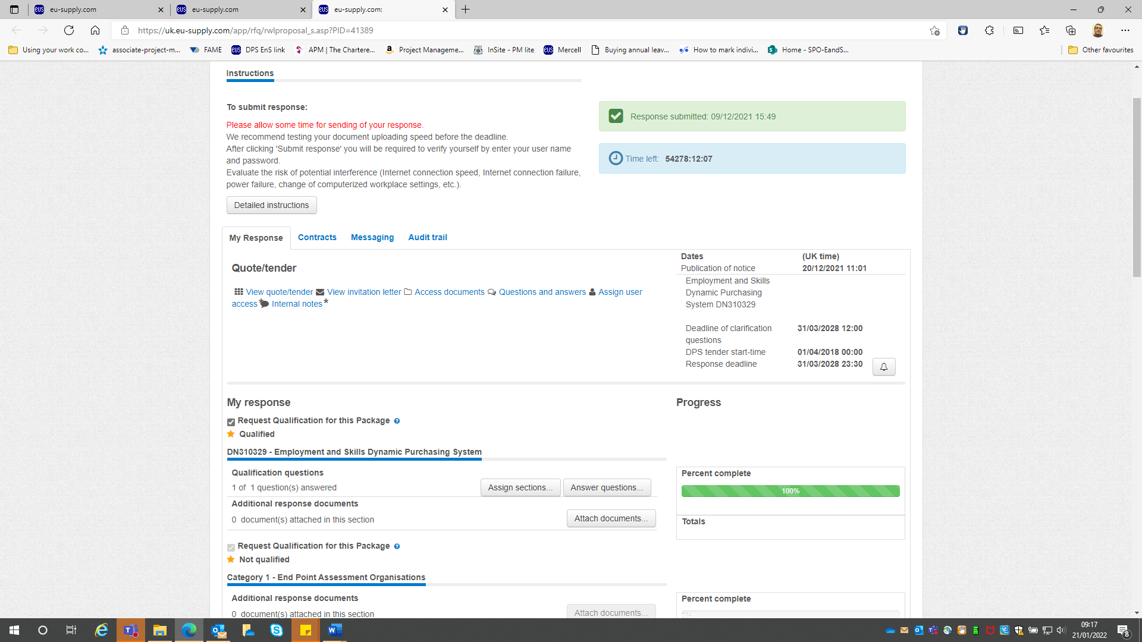

- Download all the documents but it’s only the DN310329 Selection Questionnaire YT3 word document that needs completing and submitting when applying to join the DPS

- Close Window

- Complete the Selection Questionnaire (this will take a while so you’ll need to log back into Mercell and continue at step 11 when it’s fully complete)
- Click on Answer Questions

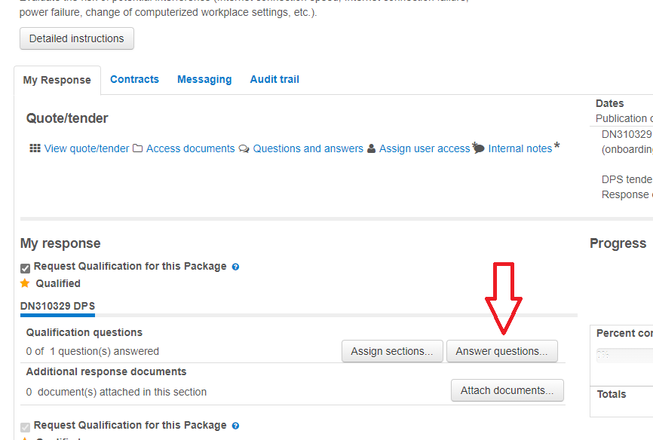

- Select We are Applying to Join DPS DN310329
- Click on ‘save and back’

- Attach your completed Selection Questionnaire

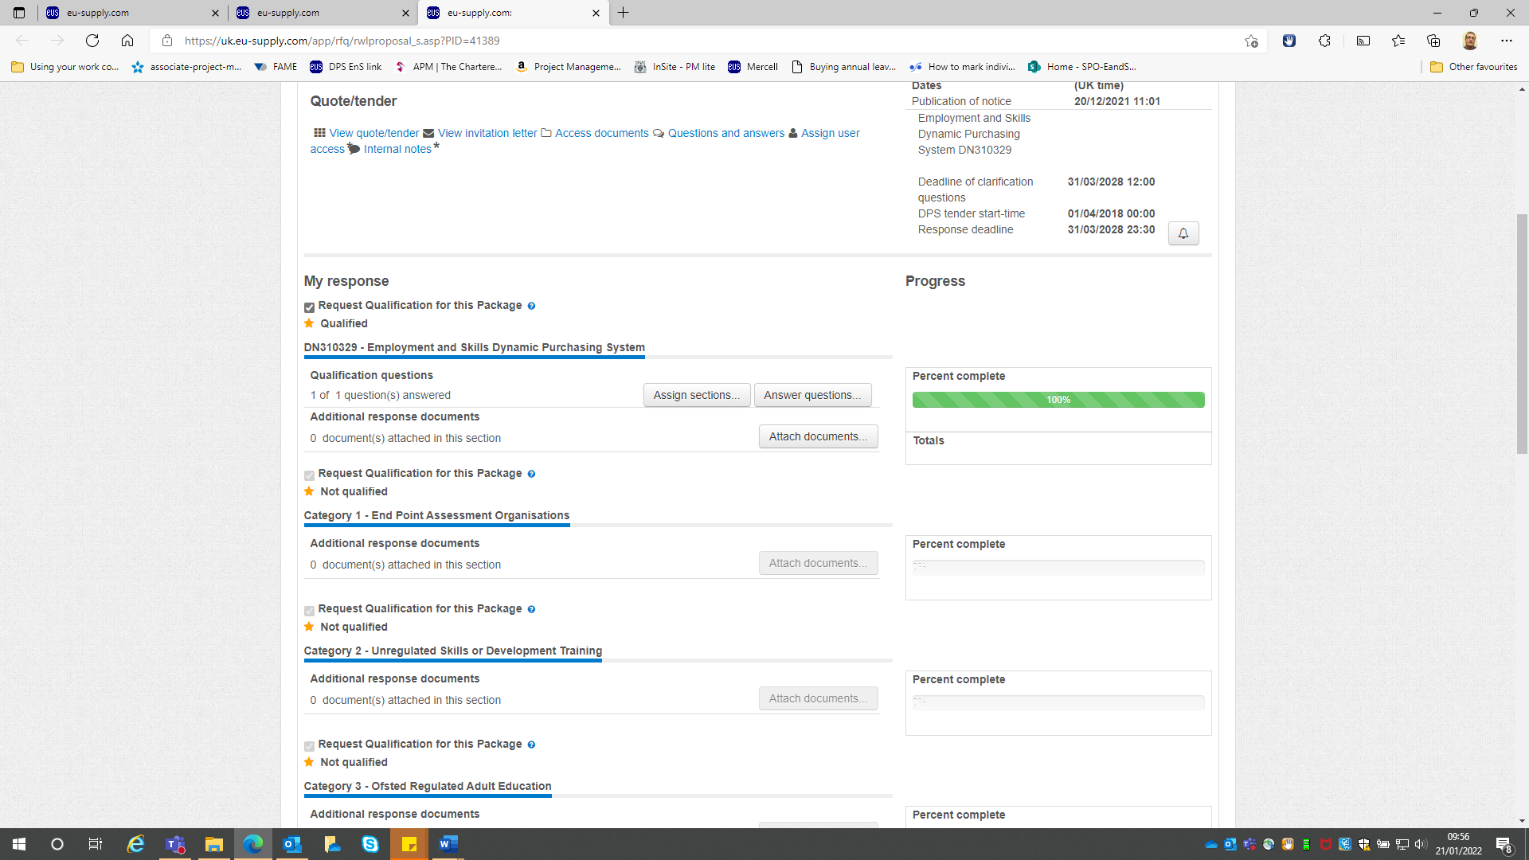

- Scroll down to the bottom of the page and click ‘Submit Response’

- Enter your user name and password and click ‘send’

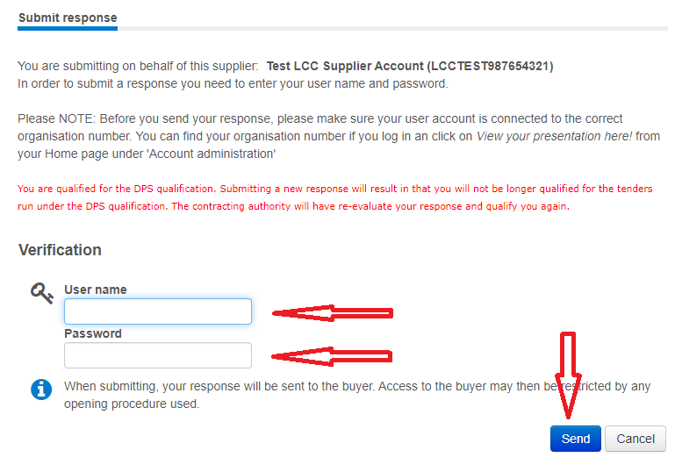

- This completes your part of the enrolment as a pre-approved supplier. The Council team will then add you into the correct DPS Categories that you were previously pre-approved in and within a few days you will see confirmation on your E&S DPS console which Categories you are qualified in, and also those not qualified in.

